The International School Bangalore
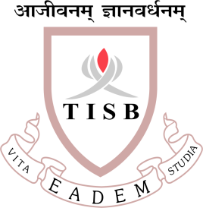
Syllabus outline Grade 11 entrance test
- States of Matter
- Atoms and Elements
- Atoms Combining
- Reacting masses and Chemical Equations
- Using moles
- Redox Reactions
- Electricity and chemical change
- Energy changes in reactions
- The rate of reaction
- Reversible reactions and equilibrium
- Acids and bases and salt
- Periodic table
- Metals
- Nonmetals and their compounds
- Organic chemistry
- Polymers
- Ions and gases

QUESTION PAPER PATTERN
· Nature of Questions: Multiple Choice Questions (MCQs)
· Number of Questions: 15
· Duration: 20 minutes

LINKS TO QP & MS
Grade11 Chemistry Answer Key.docx
Grade 11 Chemistry Entrance Test Paper.docx12

